Powerful performance, speed, and durability

[Watch Video](https://www.kingston.com/en/video/play?videoId=kq6SUKBX_kehO61tPDHyHKWQNJypN7kQ9MT9O_gnM3YrMqy8hzayZhhEblOtGN2plhXhkzWqZspKyrD7y-ceWg2&start=0&autoPlay=False&chromeless=False&captionOption=No)

SDCS2

* [Intro](https://www.kingston.com/en/memory-cards/canvas-select-plus-microsd-card#product-features)
* [Specifications](https://www.kingston.com/en/memory-cards/canvas-select-plus-microsd-card#specifications)
* [Product Comparison](https://www.kingston.com/en/memory-cards/canvas-select-plus-microsd-card#comparison-chart-1)
* [Resources](https://www.kingston.com/en/memory-cards/canvas-select-plus-microsd-card#links)
* [Datasheet](https://www.kingston.com/datasheets/sdcs2_us.pdf)

[**Buy**](https://www.kingston.com/en/memory-cards/canvas-select-plus-microsd-card#atc)

Canvas Select Plus microSD Memory Cardwith Android A1 Performance Class

Kingston’s Canvas Select Plus microSD is compatible with Android devices and designed with A1 rated performance. It offers improved speed and capacity for loading apps faster and capturing images and videos in multiple capacities up to 512GB1. Powerful in performance, speed, and durability, the Canvas Select Plus microSD is designed for reliability when shooting and developing high-resolution photos or filming and editing full HD videos. Kingston Canvas cards are tested to be durable in the harshest environments and conditions so you can take them anywhere with confidence that your photos, videos, and files will be protected. Available with a lifetime warranty.

* Class 10 UHS-I speeds up to 100MB/s2
* Optimized for use with Android devices
* Capacities up to 512GB1
* Durable
* Lifetime Warranty

Key Features



Faster speeds

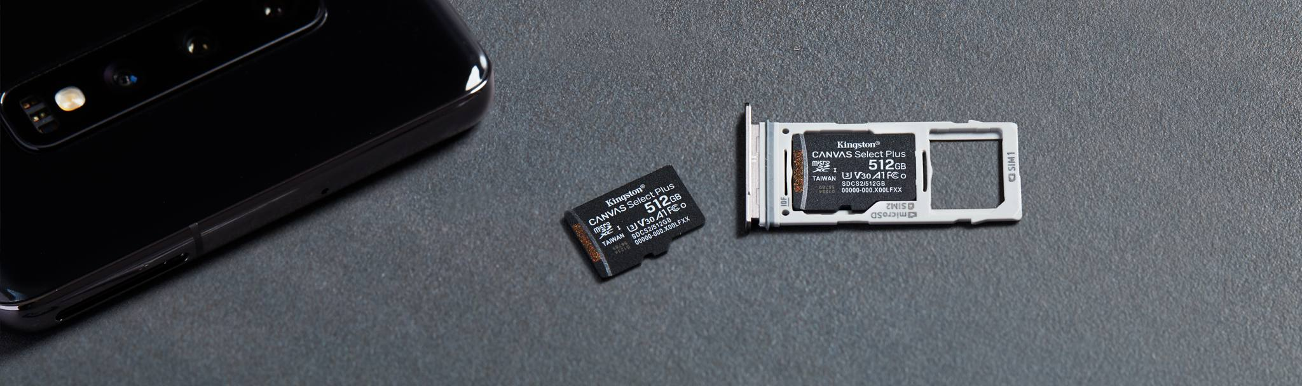

Optimized for use with Android devices

Compare microSD Cards

SDCS2

SDCG3

SDCE

SDCIT2



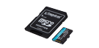

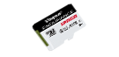

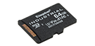

Name

Canvas Select Plus microSD

Canvas Go! Plus microSD

High-Endurance microSD

Industrial microSD

User

Consumer

Consumer

Consumer

Business/ Industrial

Capacity

64GB–512GB

64GB-1TB

32GB–256GB

8GB–64GB

Speed

100MB/s Read (64GB-128GB)  
100MB/s Read, 85MB/s Write (256GB-512GB)

•170MB/s read, 70MB/s write (64GB)  
•170MB/s read, 90MB/s write (128GB-1TB)

95MB/s Read, 30MB/s Write (32GB-64GB)  
95/MB/s Read, 45MB/s Write (128GB-256GB)

Up to 100MB/s Read, 80MB/s Write

Compatibility

UHS-I, U1, V10, A1 (64GB-128GB) UHS-I, U3, V30, A1 (256GB-512GB)

UHS-I, U3, V30, A2

UHS-I, U1, V10, A1

UHS-I Speed Class U3, V30, A1

Usage

• Point and shoot cameras  
• Android devices

• 4K Video Production  
• Action Cameras  
• Drones  
• Android Devices

• Dash cameras  
• Security cameras  
• Body cameras

• Designed and tested to be durable in extreme temperatures

[Learn more](https://www.kingston.com/en/memory-cards/canvas-select-plus-microsd-card)

[Learn more](https://www.kingston.com/en/memory-cards/canvas-go-plus-microsd-card)

[Learn more](https://www.kingston.com/en/memory-cards/high-endurance-microsd-card)

[Learn more](https://www.kingston.com/en/memory-cards/industrial-grade-microsd-uhs-i-u3)

 Reset Chart

 Remove

 Remove

 Remove

 Remove

Capacity

 64GB

 128GB

 256GB

 512GB

Adapter

 SD Adapter

 None

Packaging

 Single Pack

 Two Pack

 Three Pack

* Part Number: SDCS2/64GB

[**Where to Buy**](https://www.kingston.com/en/wheretobuy)